**Exercise**

* **Write a program to calculate CGPA using marks of three subjects (out of 100)**

**Approach:**

**So here we did like this**

**(What is the total number you got in the exam) / (total number of subject x 10)**

**Solution 👇**

**Java :**

**import java.util.Scanner;**

**public class CodeXam {**

**public static void main(String[] args) {**

**Scanner sc = new Scanner(System.in);**

**System.out.println("Enter the number of your Subject 1 (Physics) : ");**

**float a = sc.nextFloat();**

**System.out.println("Enter the number of your Subject 2 (Math): ");**

**float b = sc.nextFloat();**

**System.out.println("Enter the number of your Subject 3 (Biology) : ");**

**float c = sc.nextFloat();**

**float Total = a+b+c;**

**System.out.println("Total marks: " + Total + " out of 300");**

**System.out.println("CGPA of your 3 Subject is: ");**

**float cGPA = (Total/30);**

**System.out.println("Your CGPA is = "+ cGPA);**

**}**

**}**

**output:**

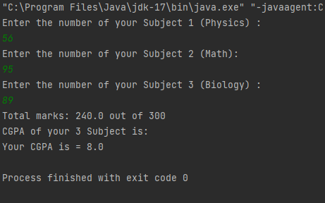

**Python :**

**sub1 = int(input("Enter the number of your Subject 1 (Physics) : "))**

**sub2 = int(input("Enter the number of your Subject 2 (Math) : "))**

**sub3 = int(input("Enter the number of your Subject 3 (Biology) : "))**

**total = sub1+sub2+sub3**

**print("Total marks :", total, "out of 300")**

**print("Your CGPA is", total/30)**

**output:**

